Angel Velazquez

10/11/2023

CST-307

Dr. Citro

CLC: I/O System Design Tool and MIPS Assembly

This program was difficult to execute without any errors. I struggled with getting a pointer to point to the last character in the inputted string. I was able to create a pointer to the address but was having problems incrementing the address to point to the last byte. I attempted using the add and addi operands, but this would result in bugs and cause the program to run incorrectly. I switched to using the addu operand and was able to increment the intended register in the way that I wanted. Implementing the algorithm to test the palindrome functions became simple once I used the addu and subu operands.

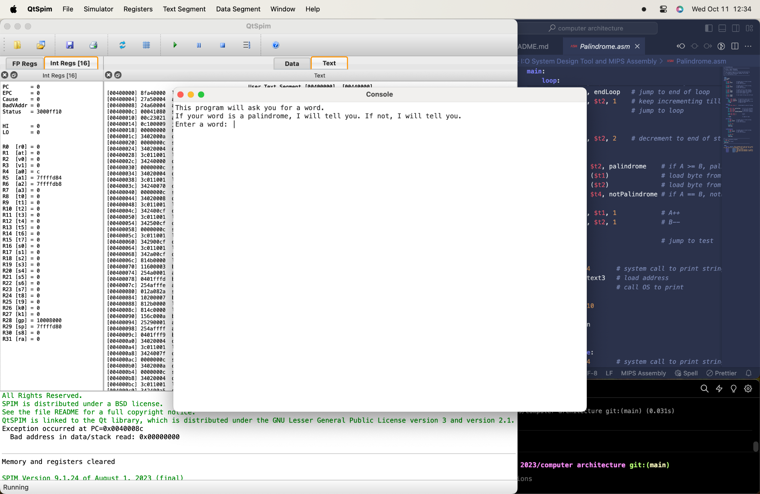

When first running the program, the console will display it’s purpose. It is to determine whether or not the word you entered is a palindrome.

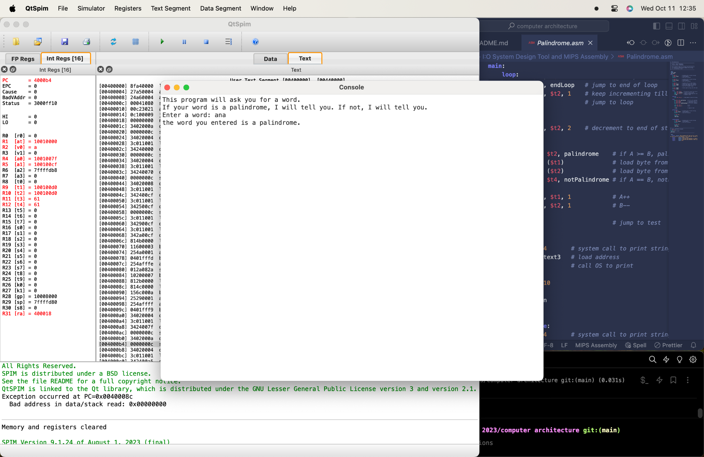

In this example, I entered the word “ana", a palindrome.

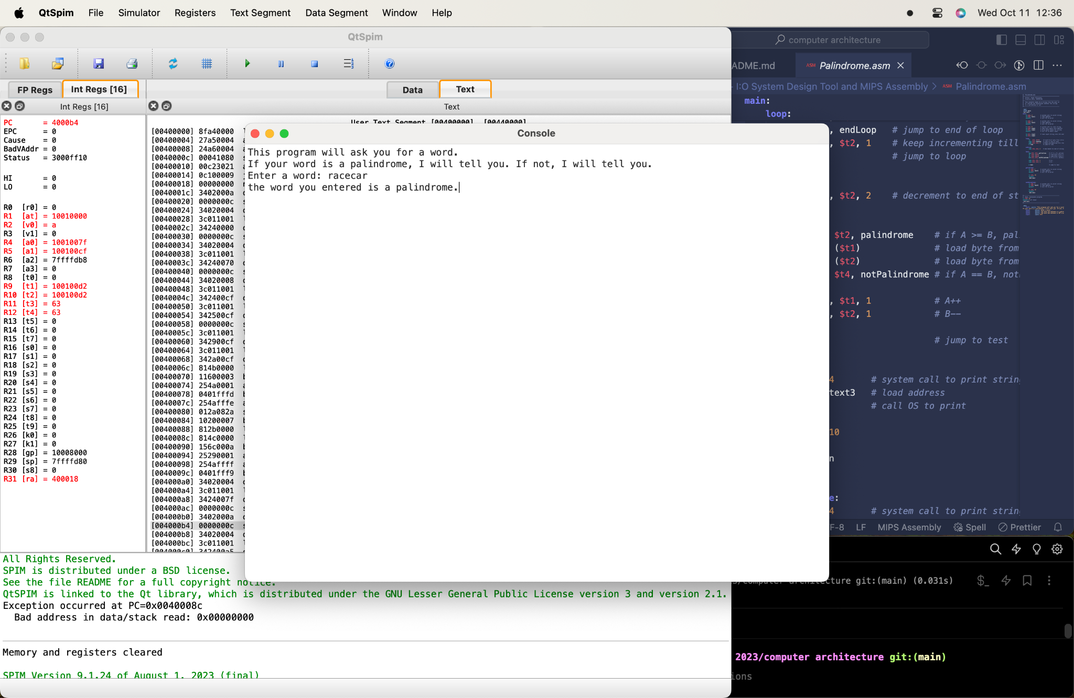

In this example, I entered the word “racecar”, also a palindrome.

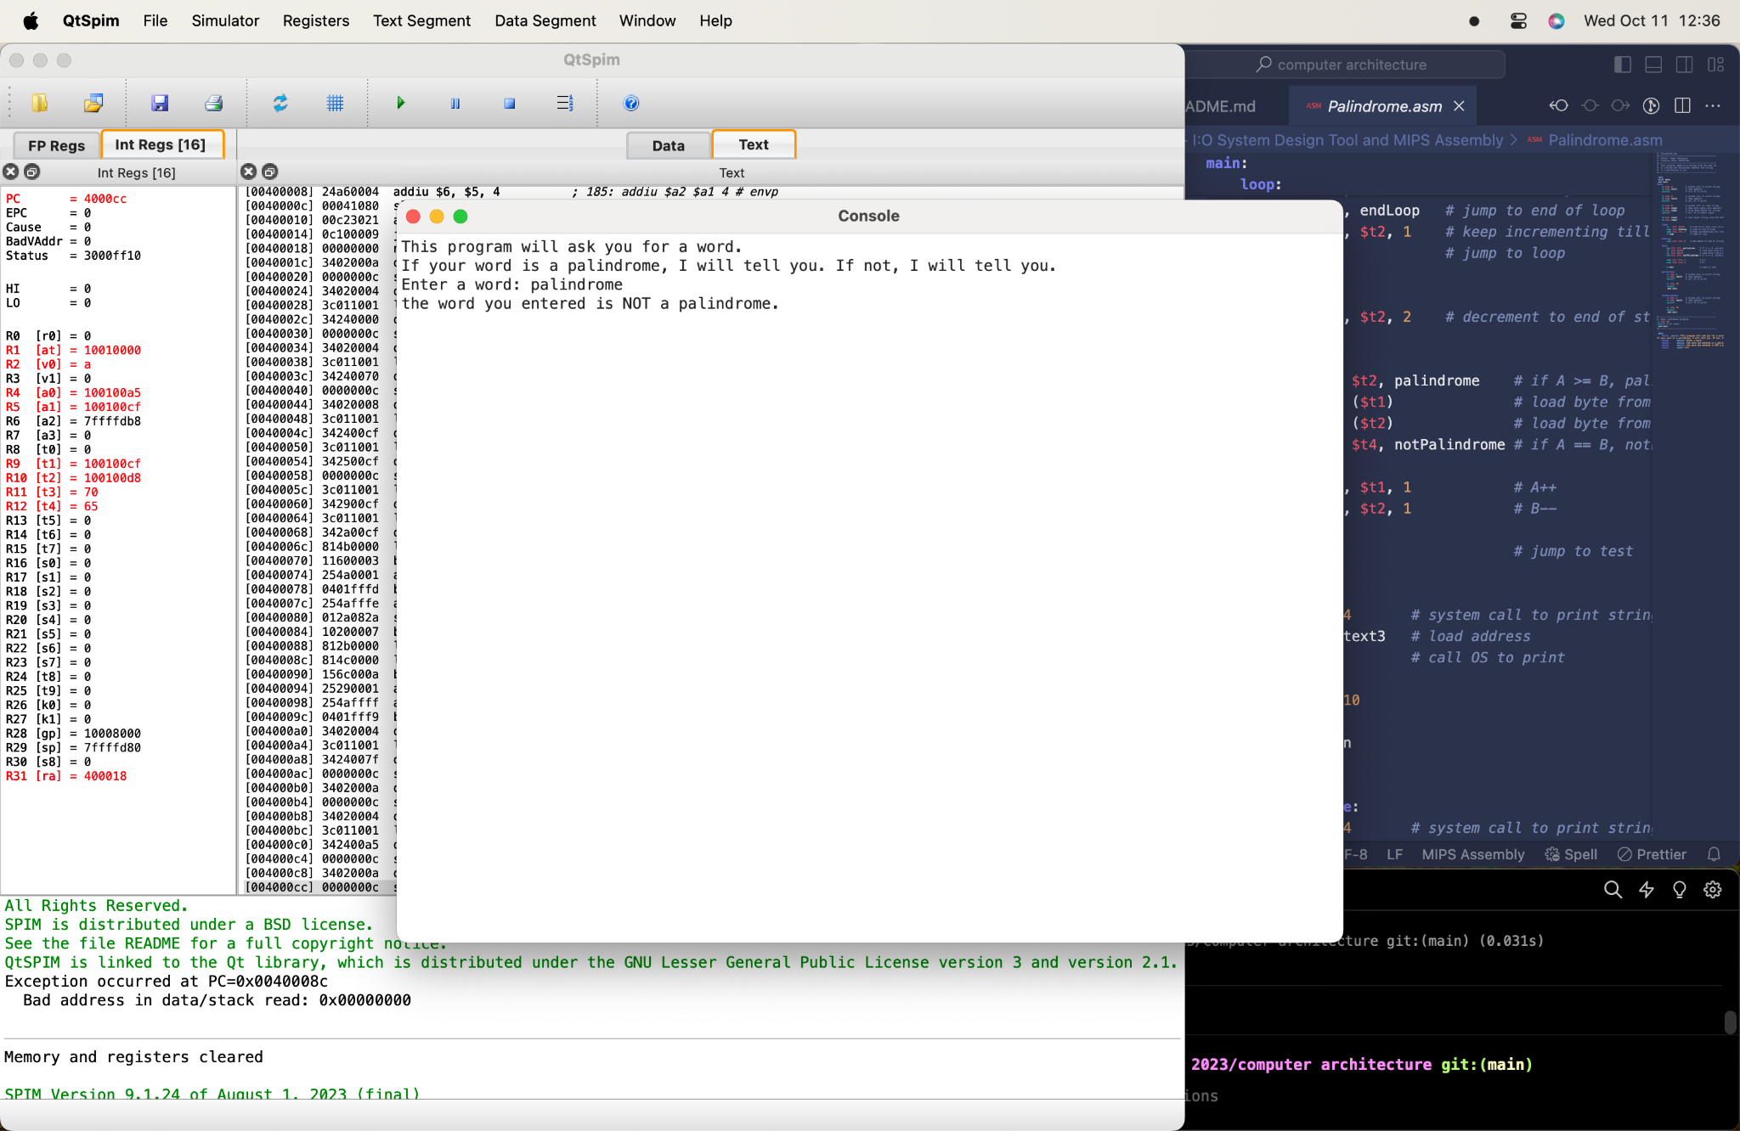

Here, I entered the word “palindrome” which is not a palindrome. The program correctly tells me that this program is not a palindrome.